Lebanese American University

Department of Computer Science & Mathematics

CSC 458 – Game Programming



Game Design Document

Data: 22/04/2021

Project: Magical Forest - Fantasy

**Project “Gaya”**

*Saving the Magical Forest*

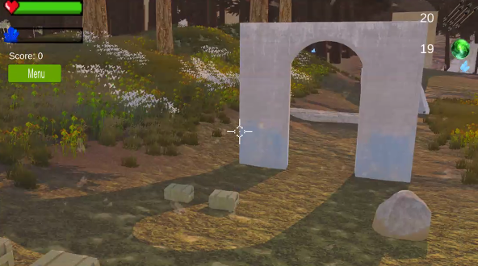**Genre:**

First Person Shooter/Role Player Games.

**Theme:**

Fantasy.

**Camera/Game Perspective:**

First Person.

**Single vs Multiplayer:**

Single player.

**Target Audience:**

13+ years old children. Our game is designed to be fun for young children. It’s only violence includes destroying pigs is a nice way and its rules are simple: collecting crystals. There is also a crystal and health bar to make it easy for young kids to understand.

**Controls:**

Keyboard + mouse.

**Tech Stack:**

Unity version 2020.3.27f1

**Platforms:**

MS Windows.

**MVP (Minimal Viable Product) Game Moment:**

You can play the game for 10 minutes which includes the collection of crystals, medical and ammo boxes in addition to killing pigs and finally placing the crystals in the temple to win.

**Game Summary:**

“Project Gaya is a first person shooter where you play in a magical forest. This magical forest contains crystals, pigs and supply boxes. You have to pick the crystals from the various locations which are protected by pigs. These pigs can be killed using your magic wand or bow. There are various medical and ammo boxes around the map that you can pick up. Once you get all the crystals, you can go to them temple and place them there to save the forest from the evil pigs.”

**Core Player Experience:**

Peaceful and fun.

**Central Story Theme:**

The protagonist is you, the hero and the main character of the game, while the antagonists are the pigs.

**Key Features:**

Player can increase his health if they are damaged by picking up medical boxes.

Player can get more ammo by picking up ammo boxes.

Player can increase his score by killing the pigs.

Player can pick up crystals to fill the crystal bar.

Player can place these crystals in the temple after picking them all to win the game.

**Game Play:**

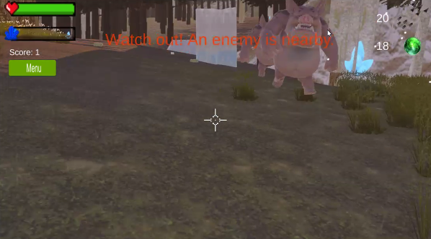

“The aim of the game is to gather all the crystals and place them in the temple.

The player can move using WSAD or arrow keys.

The player can jump using the space bar.

The player can click on the left mouse button to shoot.

The player can use T button to equip the magic wand and the Y button to equip the bow.

When the player shoots, the ammo of the used weapon decreases. If the arrow/magic ball hits the pig the enemies’ health decreases.

The player can monitor their health and crystals collected, in addition to the ammo count of each weapon and their score.

The player can click on the left mouse button to place crystals in the temple.

**Reference Games:**

None.